**Lab work 5**

**DIKSHITA-16010120006**

**YASH-16010120015**

**JINAY-16010120018**

CREATE VIEW viewitem AS

SELECT *

FROM items

WHERE iquaty>210;

SELECT*

FROM viewitem;

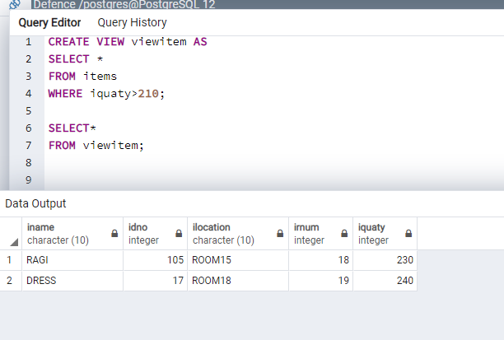

INSERT INTO viewitem(iname,idno,ilocation,irnum,iquaty)

VALUES('OATS',108,'ROOM 15',15,220)

SELECT *

FROM viewitem;

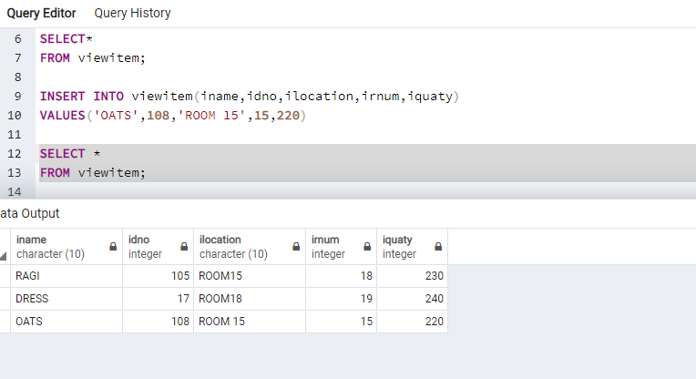

UPDATE viewitem

SET iquaty=220

WHERE iname='RAGI'

SELECT *

FROM viewitem;

DROP VIEW viewitem; 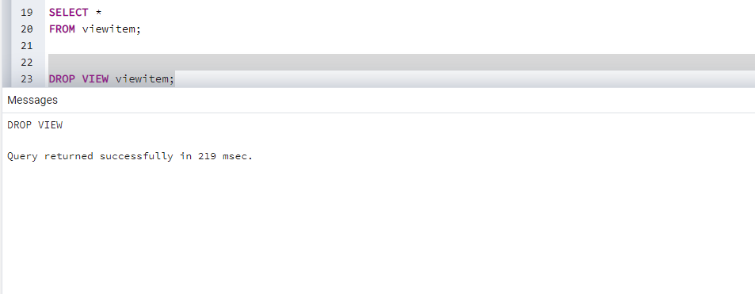



TRIGERS